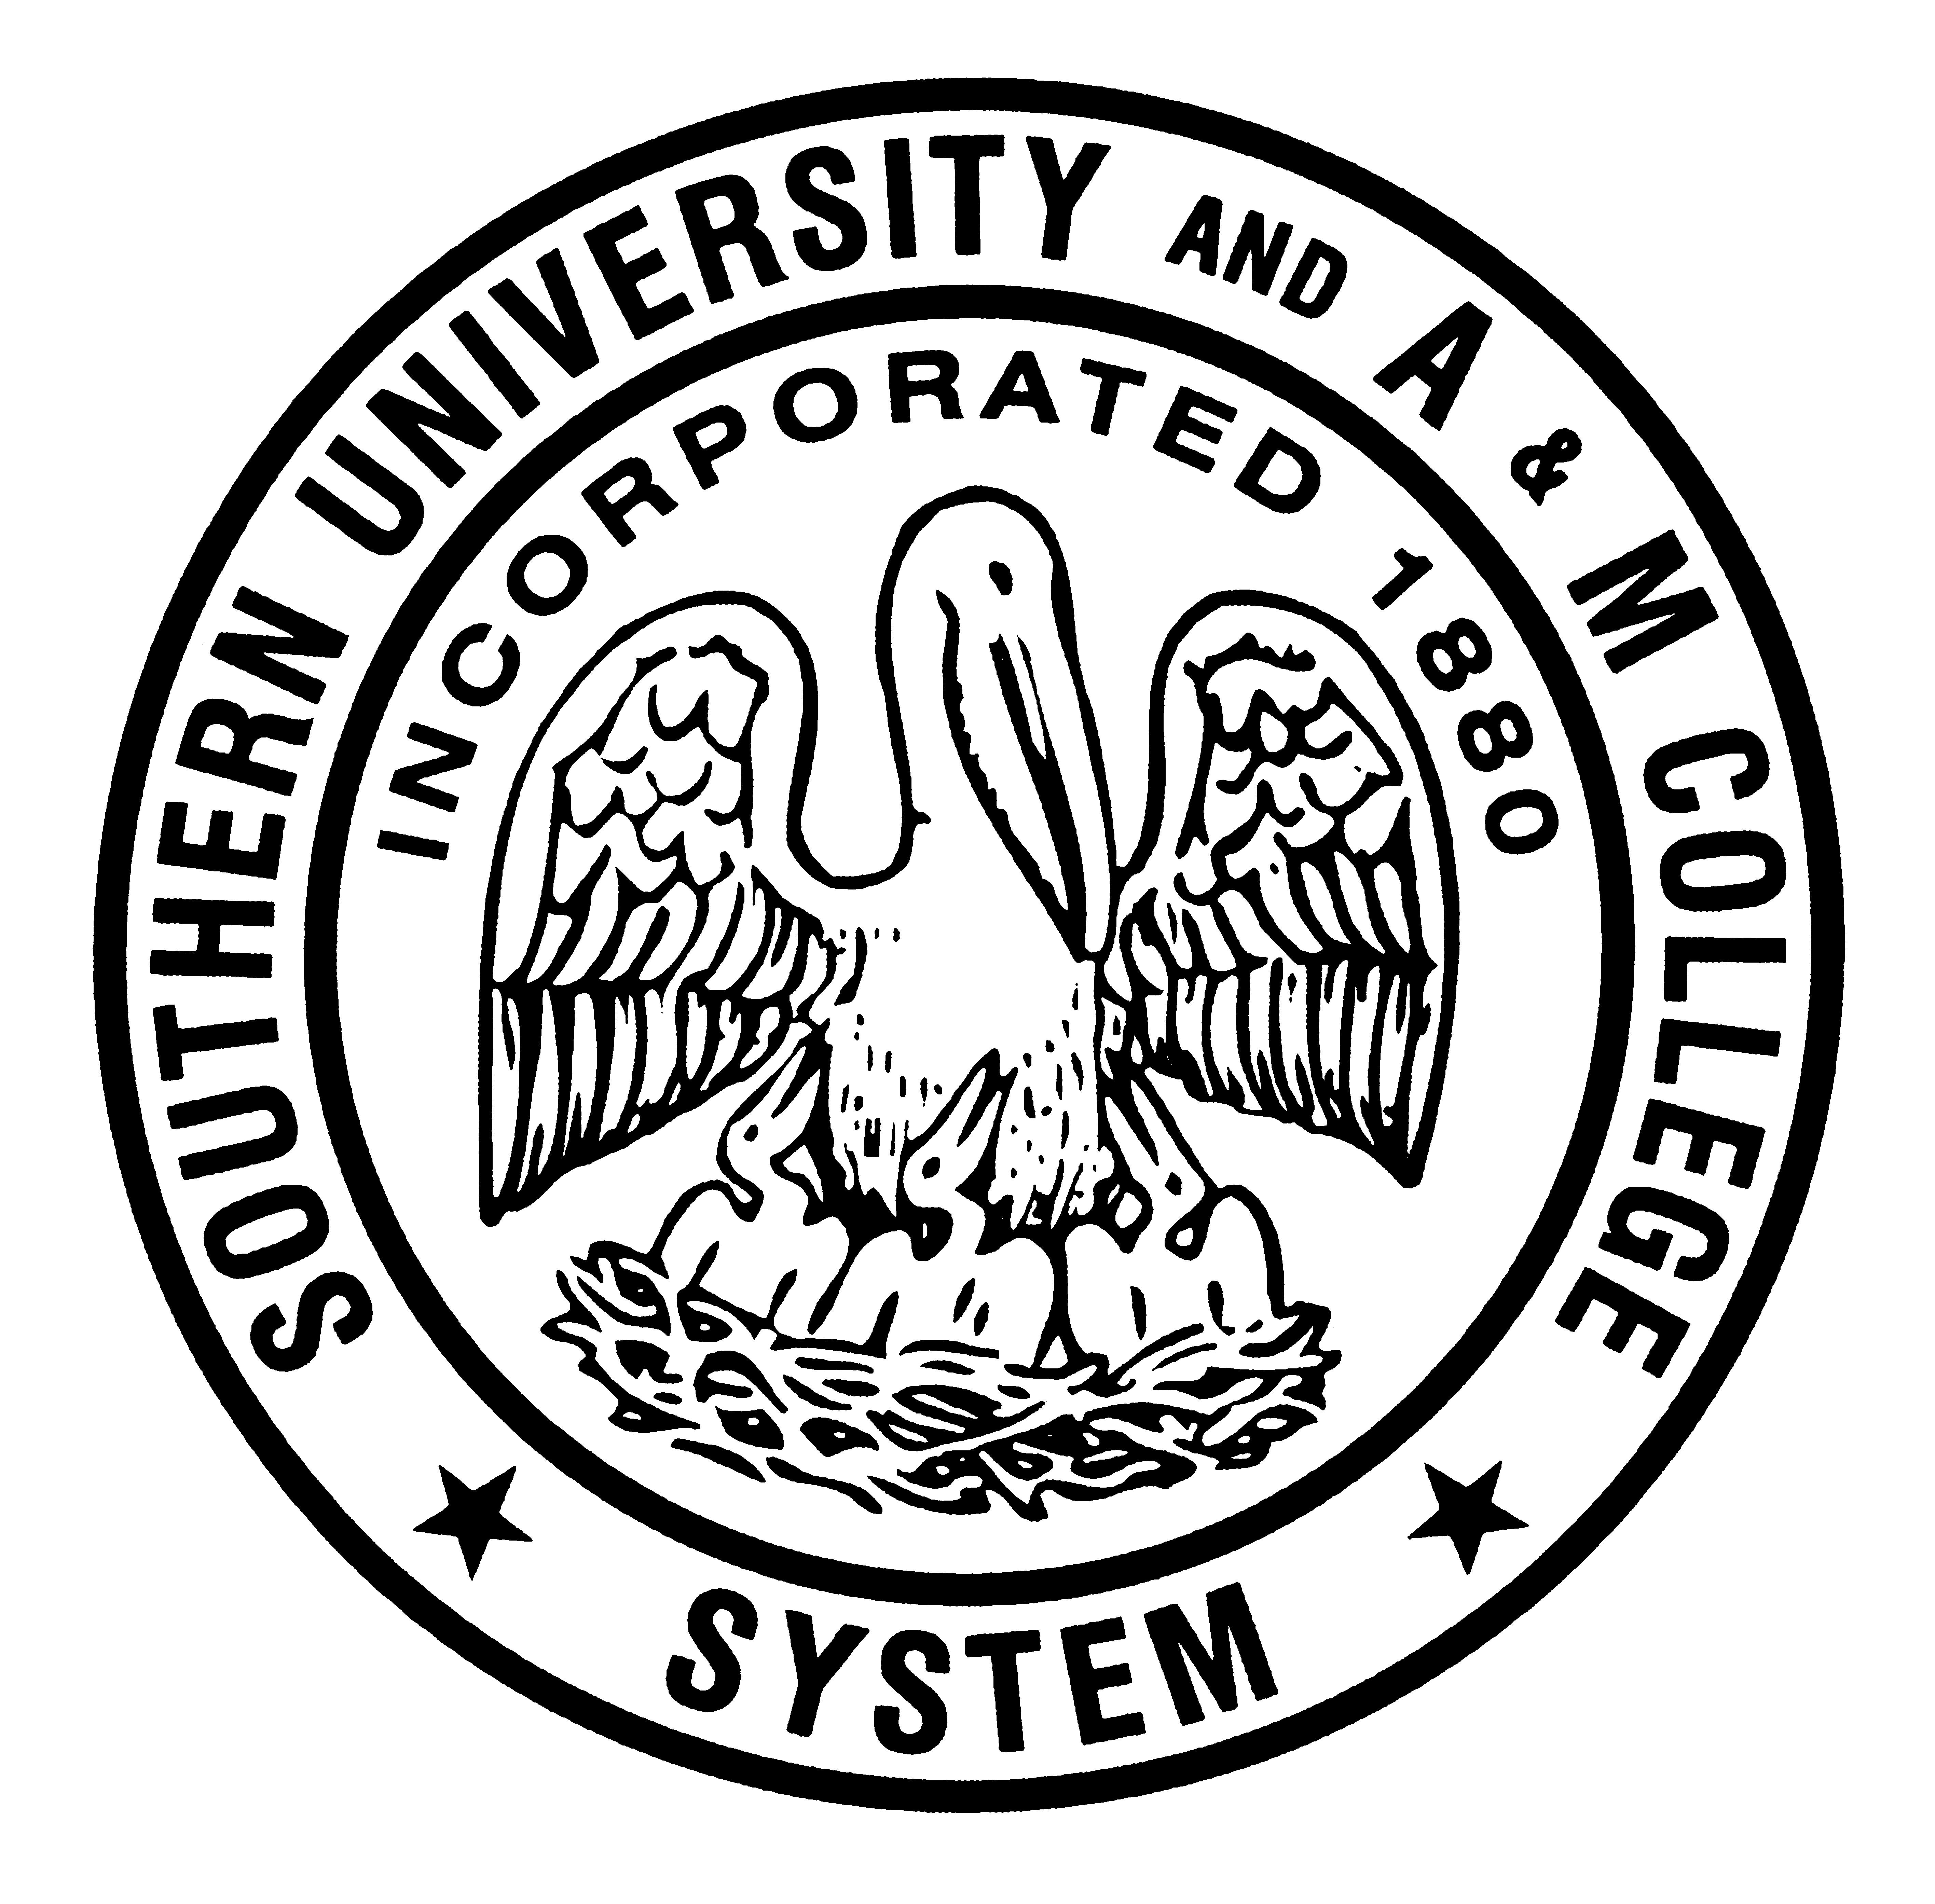

Southern University and A&M College System
Baton Rouge, Louisiana 70813

News release

January 21, 2016 Contact
Robyn Merrick
For immediate release 225.278.1756
robyn_merrick@sus.edu

Henry Tillman
225-771-5497
henry_tillman@sus.edu

SU Law Chancellor Search Committee announces applicants

A Southern University System Board of Supervisors' Chancellor Search Committee charged with assisting the SU System with selecting a new chancellor for the Southern University Law Center (SULC), announces applicants for the position.

The 14-member committee chaired by SULC alumnus Dwayne Murray, partner, Murray and Murray Law Firm, will evaluate and review the applicants’ qualifications and application packets and narrow the list to three semi-finalists.

The new chancellor will replace Freddie Pitcher Jr. who stepped down as SULC chancellor in June 2015.

The applicants are:

Joan R. Bullock, associate dean for academic affairs, associate dean for teaching and faculty development, Florida A&M University College of Law, earned a bachelor’s degree from Michigan State University, MBA from the University of Michigan, and juris doctorate from the University of Toledo College of Law.

Preston Castille Jr., partner, Taylor, Porter, Brooks & Phillips, LLP, received his undergraduate degree from Southern University Baton Rouge, and juris doctorate from Tulane University School of Law.

Monique M. Edwards, general counsel, Family First Medical Clinic, Plaquemine, consultant, South Louisiana Methanol, LLC, and adjunct professor Southern University Law Center. Her bachelor’s degree is from St. Mary’s Dominican College, and juris doctorate from the Southern University Law Center.

John Michael Guidry, State Appellate Court judge, Louisiana First Circuit Court of Appeal, has a bachelor’s degree from Louisiana State University and juris doctorate from the Southern University Law Center.

Alexander Daniel Hamilton VI, higher education consultant, earned an undergraduate degree in physics and engineering from Morris Brown College, master’s degree in education from Georgia State University, master’s degree in divinity from Yale University Divinity School, a MBA from Howard University School of Business, a juris doctorate from Howard University School of Law, and Ph.D. from the University of Illinois at Urbana-Champaign.

Russell Jones, vice chancellor for academic affairs, Southern University Law Center, earned a bachelor’s degree from Northeast Louisiana University, a juris doctorate from the Southern University Law Center, and a master of law from Georgetown University Law Center.

John K. Pierre, interim chancellor, Southern University Law Center, received a bachelor’s degree from Southern University Baton Rouge, a master’s degree from Texas Tech, and juris doctorate from Southern Methodist University, Dedman School of Law.

Jay Robinson, municipal judge, City of Dallas, Texas, earned a bachelor’s degree from the University of Texas at Austin, and a juris doctorate from the University of the Pacific McGeorge School of Law.

Roederick C. White Sr., vice chancellor for student affairs, Southern University Law Center, earned a bachelor’s degree from Southern University, and a MBA and a juris doctorate from Wayne State University.

The SULC Chancellor Search Committee’s next meeting will be announced.

About the SU System
The Southern University System was created in 1974 by constitutional mandate, which fashioned it into the Nation’s only historically black 1890 Land-Grant University System. Presently, the System is composed of five institutions: Southern University and Agricultural and Mechanical College at Baton Rouge (est. 1880), Southern University Law Center (est. 1947), Southern University at New Orleans (est. 1956), Southern University at Shreveport (est. 1964), and the Southern University Cooperative Extension Program (est. 1972), which became the fifth component of the System in 2001 and is now named Southern University Agricultural, Research and Extension Center.

# # #

