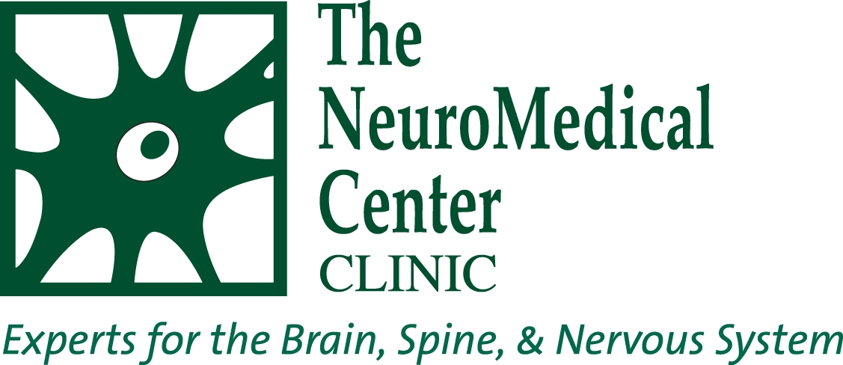

Contact:
Emily Turner, Marketing Director
(619) 948-5263
Emily.Turner@Spinehola.com
1/21/16: FOR IMMEDIATE RELEASE

NMC First to Offer New Brain Tumor Therapy
Neurologist first in B.R. to prescribe Optune

(Baton Rouge, LA) The latest in tumor treatment technology and therapy has arrived at The NeuroMedical Center and neurologist/neuro-oncologist, Dr. Jon D. Olson, is the first and only physician in the Greater Baton Rouge Area certified to prescribe Optune for the management of newly diagnosed and recurrent glioblastoma multiforme (GBM).

Optune was approved for the treatment of newly diagnosed GBM in adults 22 years of age or older by the U.S. FDA on October 5, 2015 based on the successful results of the EF-14 phase 3 trial. Optune is the first FDA-approved therapy in more than a decade to demonstrate statistically significant extension of survival in GBM patients. Although a relatively new technology, Optune has shown great promise in extending survival time for GBS patients. In clinical trials, 48% of patients treated with Optune lived at least 2 years after starting the therapy. Historically, the median overall survival time from initial diagnosis is 15 months with optimal treatment.

Optune improves the convenience and manageability of tumor treating fields (TTFields,) frequency-specific, low-intensity alternating electric fields which interrupt cancer cell structures during division and may cause cancer cells to die. The portable, non-invasive device consists of four transducer arrays that are placed directly on the scalp to target the brain tumors. The transducer array placement is based on each patient’s MRI results to maximize the therapy’s effect on the tumor. The arrays connect to a TTFields generator and a power supply which fit into a small backpack. The lightweight design allows the patient go about his or her daily activities while receiving treatment. It is recommended that the Optune system be worn by the patient 18 hours a day.

GBM is one of the deadliest forms of cancer, affecting an estimated 12,500 Americans each year. Standard treatment for GBM is surgery, followed by radiation therapy or combined radiation therapy and chemotherapy temozolomide (TMZ). If inoperable, then radiation or radiation/ TMZ is utilized.

Dr. Jon D. Olson, brain tumor specialist, is now prescribing Optune to ideal candidates at The NeuroMedical Center located at 10101 Park Rowe Ave. Suite 200, Baton Rouge, LA 70810. Patients can schedule an appointment with Dr. Olson or any of our neurological experts by calling (225) 768-2050.

